Cohesion

📌 Definition:
# Source: AI Source: Provided by: [Data Path: Persons Table -> ID Column: 1, Name_En Column: Motasem Essam] -> From: [Chatgpt (GPT‑5 Mini)] on [12/9/2025]
Cohesion refers to the degree to which the elements inside a class or module belong together and work toward a single, well-defined purpose.

🧠 Simple idea:
# Source: AI Source: Provided by: [Data Path: Persons Table -> ID Column: 1, Name_En Column: Motasem Essam] -> From: [Chatgpt (GPT‑5 Mini)] on [12/9/2025]
Cohesion = “How focused a class is” 🎯

🔍 Key characteristics:
# Source: AI Source: Provided by: [Data Path: Persons Table -> ID Column: 1, Name_En Column: Motasem Essam] -> From: [Chatgpt (GPT‑5 Mini)] on [12/9/2025]
- 🧩 Measures internal consistency of a class
- 🎯 High cohesion → class has a single responsibility
- ⚙️ Improves readability and maintainability
- 🧠 Makes code easier to understand and reuse
- 🎯 Goal: keep cohesion high

📊 Types of Cohesion:

Based on overall focus
# Source: AI Source: Provided by: [Data Path: Persons Table -> ID Column: 1, Name_En Column: Motasem Essam] -> From: [Chatgpt (GPT‑5 Mini)] on [12/9/2025]
• 🟢 High Cohesion → Class/module focused on one task or responsibility
• 🔴 Low Cohesion → Class/module does multiple unrelated tasks

Based on degree/type of internal relatedness (spectrum)
# Source: AI Source: Provided by: [Data Path: Persons Table -> ID Column: 1, Name_En Column: Motasem Essam] -> From: [Chatgpt (GPT‑5 Mini)] on [12/9/2025]
• 🟢 Functional Cohesion (Best / Highest) → All elements serve one specific task
• 🟢 Sequential Cohesion → Elements form a sequence where output of one is input of next
• 🟢 Communicational / Informational Cohesion → Elements work on same data or output
• 🟡 Procedural Cohesion → Elements follow a specific procedure/order
• 🟡 Temporal Cohesion → Elements occur at same time (e.g., initialization)
• 🟠 Logical Cohesion → Elements are logically related but perform different tasks
• 🔴 Coincidental Cohesion (Worst / Lowest) → Elements randomly grouped with no relationship

⚙️ Benefits of high cohesion:
# Source: AI Source: Provided by: [Data Path: Persons Table -> ID Column: 1, Name_En Column: Motasem Essam] -> From: [Chatgpt (GPT‑5 Mini)] on [12/9/2025]
- 🧠 Better code clarity
- 🔄 Easier maintenance
- ♻️ Improved reusability
- 🧩 Cleaner design

🆚 Cohesion vs Coupling:
# Source: AI Source: Provided by: [Data Path: Persons Table -> ID Column: 1, Name_En Column: Motasem Essam] -> From: [Chatgpt (GPT‑5 Mini)] on [12/9/2025]
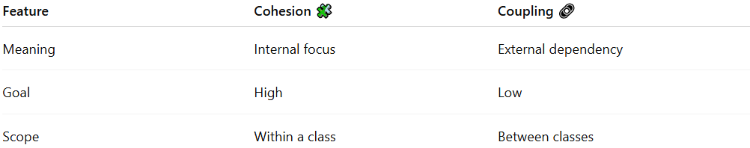
Feature | Cohesion 🧩 | Coupling 🔗
Meaning | Internal focus | External dependency
Goal | High | Low
Scope | Within a class | Between classes

🎯 Real-world idea:
# Source: AI Source: Provided by: [Data Path: Persons Table -> ID Column: 1, Name_En Column: Motasem Essam] -> From: [Chatgpt (GPT‑5 Mini)] on [12/9/2025]
- 🧱 A well-designed class = does one job well
- ❌ A messy class = does everything (bad design)

🎯 Summary:
# Source: AI Source: Provided by: [Data Path: Persons Table -> ID Column: 1, Name_En Column: Motasem Essam] -> From: [Chatgpt (GPT‑5 Mini)] on [12/9/2025]
Cohesion measures how well a class is focused on a single responsibility, and good design aims for high cohesion to create clear and maintainable code.

